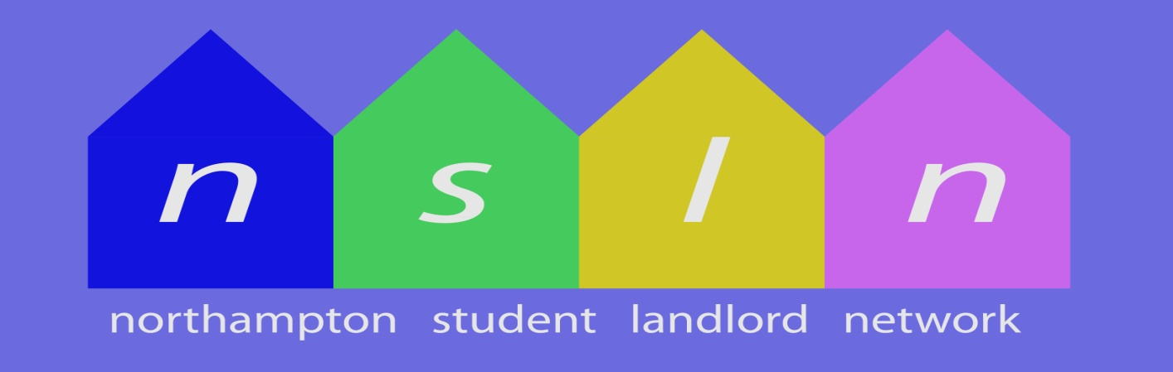

Key Objectives:-
- Information & Guidance
To provide specific & timely information & guidance to both landlords & students
- Communication Network
To facilitate an effective communication network for landlords letting to students
- Positive Voice
To provide a representative and positive voice for our members

Great Advice ………..
Great Support ………..
FOR LANDLORDS & STUDENTS

What We Do:-
- Keep Landlords Informed
- Help students find their perfect home
- Offer advice on Contracts, Deposits and Fees
Rich Dawson  (NSLN Chairman) | Susan Dowding | Jenny Cross | Richard Lee

